**Agile Group Project 2018**

**Design Document**

Introduction

This document outlines the design for the Toguz Korgool game. It contains both the class diagram and the use case diagram for playing Toguz Korgool. In addition to this, wireframes for the user interface are also included.

User Interface

**Overall Architecture**

For our project we decided to split the front end (e.g. GUI) and back end (e.g. calculating if a move causes a Tuz) features into separate classes as much as possible. This can be seen in the class diagram below.

Class Diagram

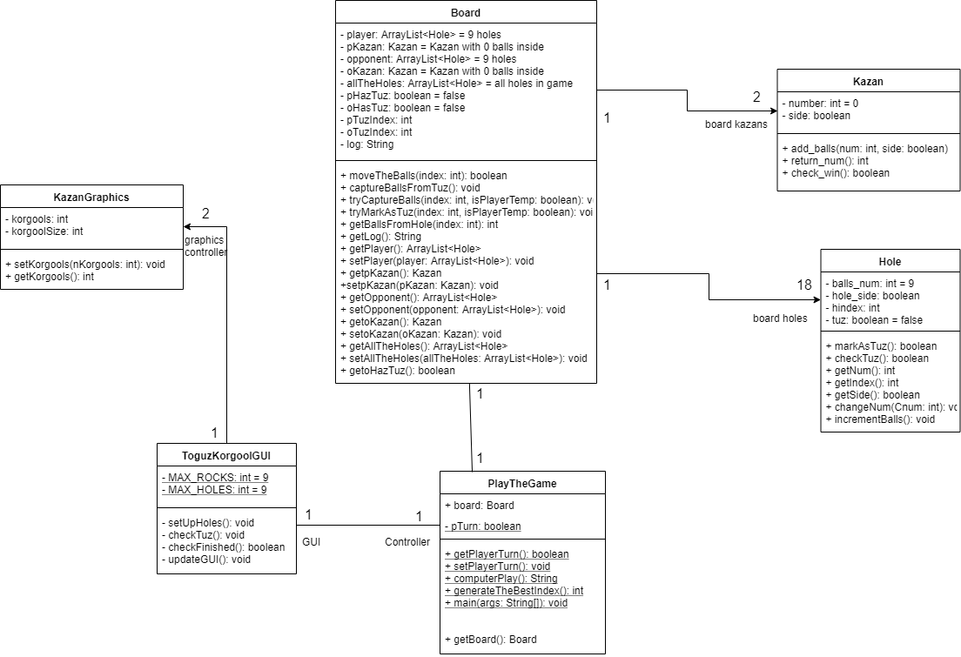

Above is the class diagram. This shows the fields and methods of the classes. A ‘+’ denotes the field/method is public and a ‘-‘ is to show it is private. Excluded from this diagram is some of the GUI classes for the start page as they are not relevant to the core functionality of the game as so would be irrelevant and clutter the diagram.

Use Case Diagram

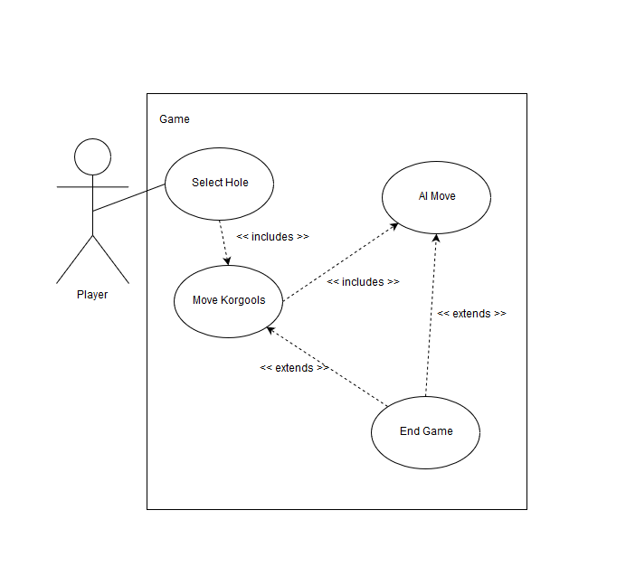

This is the use case diagram for the Toguz Korgool game when playing against the computer.